APPLICATION FORM  Innovation & IP Market at BIP Asia Forum |  |  |  | Early-Bird Application Deadline  提前報名優惠截止日期  31/7/2023
「亞洲知識產權營商論壇」創科營商廊 - 參展申請表
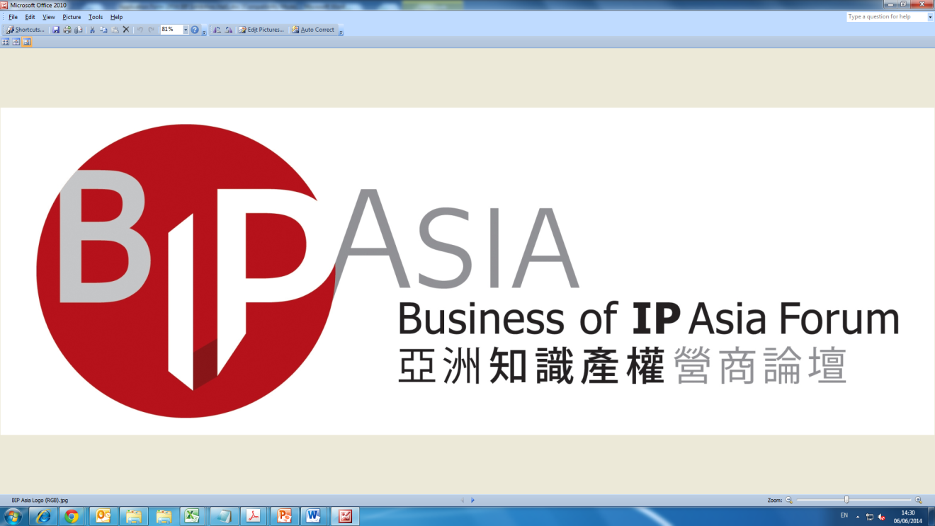

Organisers 主辦機構  7-8 December 2023 |  |  |  | 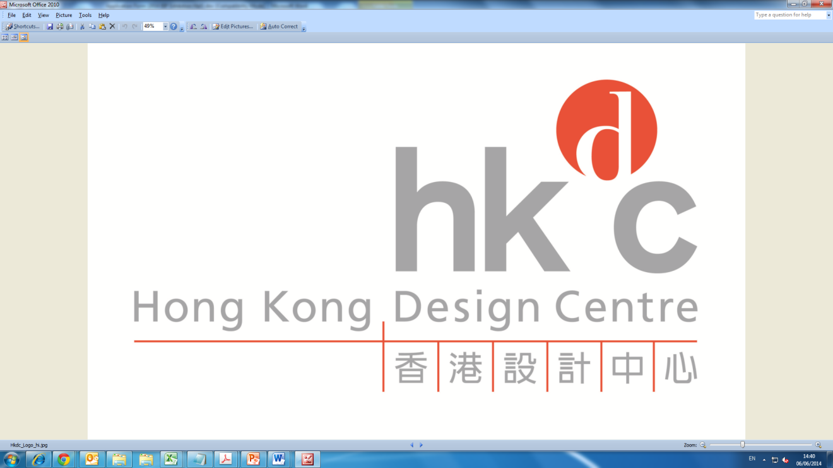
Important 重要事項
- All Information must be completed in English unless otherwise stated. 除註明外，所有資料請以英文填寫。
- Entry for “Company Name” will be used for booth fascia and Entry for “Company Information” will be used for publicity and publication in conference website. 公司名稱將用作攤位之公司招牌，所有公司資料將用於宣傳及論壇網站。
- In the event of any inconsistency between the Chinese version and the English version, the English version shall prevail. 所有中文譯本祇供參考，若中文譯本與英文版本之文義有異， 一概以英文版本為準。
- Please email the completed application form to: 請將填妥之申請表電郵至: yvonne.py.kan@hktdc.org / miffy.ch.cheung@hktdc.org
- Inquiries 查詢 : Ms Yvonne Kan / Ms Miffy Cheung (Tel: 2584 4187 / 2584 4316)
- Company Information 公司資料
1a. | Company Name in English | Click or tap here to enter text.
1b. | 中文公司名稱 (if any) | Click or tap here to enter text.
2. | Registered Office Address  公司登記地址 | Click or tap here to enter text.
 |  | Click or tap here to enter text.
 |  | Click or tap here to enter text.
 | Correspondence Address  通訊地址  Same as above 同上 | Click or tap here to enter text.
 |  | Click or tap here to enter text.
 |  | Click or tap here to enter text.
3. | Tel No. 電話 | Click or tap here to enter text. | 4. Fax No. 傳真 |  | Click or tap here to enter text.
5. | Company Email公司電郵 | Click or tap here to enter text.
6. | Web-Site網址 | Click or tap here to enter text.
 | For HKTDC Contact only | 只供香港貿發局聯絡之用
7. | Contact Person 聯絡人  有關參展事宜之聯絡人  有關參展事宜之聯絡人 | Click or tap here to enter text.
8. | Contact Email* 聯絡電郵*  Same as above 同上  有關參展事宜之聯絡人  有關參展事宜之聯絡人 | Click or tap here to enter text.  Email is our primary mode of contact, please provide an email address that is frequently used. 電子郵件是主要的聯繫方式, 請提供經常使用的電郵地址.
9. | Contact Tel No. 聯絡電話 | Click or tap here to enter text.
10 | Mobile No. 手提電話  ()  () | Click or tap here to enter text.
11. | Nature of Business 業務性質 1. IP Service Provider 知識產權服務供應商 2. IP Owner 知識產權擁有者  Owners
 | (Please select one 請選一項) 3. Government/IP Organisations 政府/知識產權機構 4. Media 媒體
 | 5. Others (please specify) 其他 (請註明): _ Click or tap here to enter text. _________________________

- Company Profile and Logo 公司簡介及商標

I have provided company profile and logo via this link for publicity and publication in the conference booklet (if any) and forum website.
我已提供公司簡介及商標至此連結, 以供宣傳、論壇場刊(如有)及網站之用。
- Exhibition Fee 參展費用
 | Booth Option  展台類別 |  |  | Standard Fee |  | Early-bird Discount¹ (HK$)  提早報名優惠¹ (港幣) |  | No. of booth | Total Participation Fee
 |  |  |  | 標準費用 (港幣) |  | Past Exhibitors²  舊參展商² | New Exhibitors  新參展商 | 展台數目 | 參展費合計
 | 6 sqm Standard Booth  6 平方米展位 |  |  | HK$14,500 |  | 10,150 | 11,600 |  | HK$
 | 9 sqm Standard Booth  9 平方米展位 |  |  | HK$19,800 |  | 13,860 | 15,840 |  | HK$
 | 18 sqm Standard Booth  18 平方米展位 |  |  | HK$30,500 |  | 21,350 | 24,400 |  | HK$

Remarks備註

Early-bird discount is only offered to applications submitted on or before 31 July 2023.

提早報名優惠只適用於2023年7月31日或之前提交之報名表格。

30% early-bird discount is only offered to past exhibitors of BIP Asia Forum from 2019 to 2022.

7折提早報名優惠只適用於2019-2022年亞洲知識產權營商論壇的舊參展商。

Allocation of booth location will be at the final discretion of the Organiser. 主辦機構保留權利作最後展位位置之分配。

The Organiser reserves the right to change the booth assignment and/or amend the floorplan at anytime without giving notice to the exhibitor. 主辦機構保留權利隨時更改展覽會之圖則及展位位置，無須通知參展商。

Final decision will be made at the discretion of the Organisers. 主辦機構保留最終決定權。

 | - Application and Payment Method 報名及繳費方式

Please return the application form on or before the application deadline (31 July 2023).

請於截止報名日期前 (2023年7月31日) 把參加表格交回香港貿易發展局。

by Bank Transfer (Please note that all remittance charges are to be borne by the remitter)

銀行轉帳 (所有匯款費用由匯款人承擔)

Account Holder 賬戶持有人: Hong Kong Trade Development Council 香港貿易發展局

HKD account 港幣帳號: 004-002-222701-001

Bank 銀行: The Hongkong and Shanghai Banking Corporation Limited 香港上海匯豐銀行有限公司

Bank Address 銀行地址: 1 Queen’s Road Central, Hong Kong 香港中環1號皇后大道中

Swift Code 代碼: HSBCHKHHHKH

Please quote the contact person, company name and "BIP Asia" on the remittance advice and e-mail to

請於銀行匯款通知上(「水單」)寫上聯絡人、公司名稱及「BIP Asia」並電郵至

yvonne.py.kan@hktdc.org / miffy.ch.cheung@hktdc.org.

by Cheque 支票付款

Payable to 支票受款人: Hong Kong Trade Development Council 香港貿易發展局

Mailing Address 郵寄地址: 38th Floor, Office Tower, Convention Plaza

1 Harbour Road, Wanchai, Hong Kong

(Attn: Ms Yvonne Kan / Ms Miffy Cheung)

- Company Stamp and Signature公司印章及簽名

We (Name of Company) 本公司（公司名稱）
hereby apply to participate in the BIP Asia Forum 2023. We understand that the Exhibition Fee is non-refundable once our Application is accepted.
申請參加2023「亞洲知識產權營商論壇」。本公司明白參展申請一經接納，參展費用將不獲退回。

We agree to abide by the provision of all documents forming part of the Application Form, including but not limited to, the below “Conditions of Participation” as may be amended and updated from time to time by the Hong Kong Trade Development Council (the “Organiser” / “Council” / “HKTDC”). 本公司亦同意遵守香港貿易發展局 (“香港貿發局”/“主辦機構”) 在此申請表上訂定的所有條款，包括但不限於下頁的參展細則及展覽規例(會被不時修訂或更新)。

I acknowledge that the above information may be used by the Hong Kong Trade Development Council (HKTDC) for incorporation in all or any of its databases for direct marketing or business matching purpose, and for any other purposes as stated in the Privacy Policy Statement (available at www.hktdc.com/mis/pps/en); I confirm that I have the consent and the authority of each individual named in this form to release their personal data for the purposes stated herein. We agree that the Organiser bears no responsibility for any error or omission in relation to the information. 本人確定香港貿易發展局 (“貿發局”) 可將上述資料編入其全部或任何資料庫內作為直接推廣或商貿配對，以及用於貿發局在私隱政策聲明〔載於網頁 http://www.hktdc.com/mis/pps/tc〕中所述之其他用途。本人確認已獲得此表格上所述的每一位人士同意及授權，將其個人資料提供予貿發局作此表格提及的用途。本公司同意，主辦機構毋須負責任何有關該等資料的錯漏。

We hereby declare that the information given in the application form is true and correct. We consent to the Council’s checking with Customs and Excise Department and other relevant authorities regarding our trade records. We understand that any false or misleading information given by us to the Council may lead to the rejection of our right to participate in BIP Asia Forum 2023 at the Council’s sole and absolute discretion. 本公司鄭重聲名所有於申請表上填寫之資料均為真實及正確。本公司同意香港貿發局向香港海關及其他有關當局調查我們的貿易記錄。本公司明白倘若提供任何虛假或欺騙之資料，香港貿發局將有權以其唯一及絕對酌情權拒絕本公司參加2023「亞洲知識產權營商論壇」的權利。

We hereby warrant, represent and undertake to the Organiser that the photographs and/or materials provided by us and/or publication by HKTDC of such photographs and/or materials do not and will not in any way whatsoever violate or infringe any third party’s rights including all intellectual property rights including but not limited to trade marks, copyrights, designs, names and patents whether registered or otherwise. We hereby acknowledge and irrevocably undertake to fully indemnify the Organiser and/or its agents, representatives, contractors and employees against all costs, expenses and damages arising from any third party’s claim of infringement against us and / or the Organiser and / or the Organiser’s agents, representatives, contractors or employees of such third party’s rights. 我們在此向主辦機構保證、表示及承諾，我們提供的相片及/或資料及/或香港貿發局發布該等相片及/或資料没有及不會違反或者侵犯任何第三者的權利包括所有知識產權(包括但不限於商標、版權、設計、名字和專利，無論是否註冊)。我們在此向主辦機構確認和不可撤銷地承諾，我們將完全彌補主辦機構以及其代理人、代表人、承辦商和僱員就任何有關第三者向我們及/或主辦機構以及其代理人、代表人、承辦商和僱員採取任何關於侵犯第三者權利的申索之所有費用、開支和賠償。

If you do not wish to have your information pass on to third parties for promotion of BIP Asia Forum 2023, please check this box.

若貴公司不欲將有關資料轉交其他機構作為推廣2023「亞洲知識產權營商論壇」之用，請選取此空格。

I would like to continue to be part of HKTDC's contact list and be informed of the latest market intelligence and business opportunities. (This box is solely for European Union (“EU”) / European Economic Area (“EEA”) customers as required by the relevant data protection law in the EU.)
本人願意繼續加入貿發局的聯絡名單，以獲悉最新的市場信息和商機。(此選項是按歐盟有關保護個人資料法律的要求而設，只適用於歐盟 / 歐洲經濟區的客戶。)

Company Stamp & Authorised Signature  公司印章及負責人簽名 |  | Date  日期
Full Name of Authorised Signer  負責人姓名 |  | Position  職位

CONDITIONS OF PARTICIPATION

1. DEFINITIONS
In these Conditions of Participation and the Application Form, save as the context otherwise requires:
"Applicant" means the company named in Section A of the Application Form.
"Application" means the application by the Applicant to participate in the BIP Asia Forum, made by submitting the Application Form together with all necessary payments to the Council.
"Application Form" means the application form to which these conditions are annexed.
"Booth" means a booth in the BIP Asia Forum, which the Council licenses the Participant to use for the duration of the Exhibition.
"Conditions" means these Conditions of Participation as amended by the Council from time to time.
"Council" means the Hong Kong Trade Development Council.
"Exhibition" means the fair or exhibition named in the Application Form.
"Hong Kong" means the Hong Kong Special Administrative Region of the People's Republic of China.
"Exhibition Hall" means the exhibition organised by the Council to accommodate all participants, which will be built on a specified location assigned by the fair/exhibition organiser;
"Optional Participation Expenses" means the amount payable by each Participant for additional facilities and services such as shipment of samples, extra stand facilities and interpreters, provided by the Council at its request, which amount shall be determined by the Council.
"Participant" means the Applicant after its Application has been accepted by the Council.
"Exhibition Fee" means the amount payable by the Participant to the Council for the right to participate in the BIP Asia Forum, as specified in Section C of the Application Form.
"Publicity Material" means all and any promotional gifts, catalogues, pamphlets, advertising and publicity material whatsoever which the Participant wishes to display, distribute or use at or for the purpose of the Exhibition.
2. ACCEPTANCE
(a) The Executive Director, on behalf of the Council, may in his absolute discretion accept or reject the Application without providing any reasons therefor.
(b) The Applicant represents and warrants that none of its Related Companies, associates, or persons or companies that are effectively under its control has applied to participate in the BIP Asia Forum. The Council has an absolute discretion to reject the Application or withdraw its acceptance of the Application if the Applicant shall have breached this warranty and representation.
(c) The Applicant is not allowed to exhibit products or materials that would infringe the intellectual property rights of others or that have caused the Applicant accusation or conviction of criminal or civil liability in IPR infringement claim. If the Applicant refuses to co-operate with the Council, the Council reserves the right to ban the Applicant, or any of its parent, associate, affiliated and/or subsidiary company, from participating in any future .
3. Payment
(a) Upon submission of its Application, the Applicant shall pay to the Council such amounts and in such manner as set out in the Application Form.
(b) If the Applicant has requested for additional facilities and services, it shall further pay to the Council upon submission of its written request for such services and facilities:
i. the full amount as the Council in its sole discretion considers appropriate for the Optional Participation Expenses if such request is made prior to the commencement of the Exhibition and on-the-spot during the Exhibition.
(c) If the Application is rejected, the Council will within 30 days of the date of notice of rejection refund to the Applicant all amounts received by it from the Applicant pursuant to paragraphs 3(a) and 3(b) above without interest.
(d) When the Application is accepted by the Council, the Applicant will become a Participant. If it subsequently wishes to withdraw its participation, it may do so by notice in writing to the Council whereupon the Participation Fee will be forfeited by the Council. All Optional Participation Expenses paid by the Participant for the optional and additional facilities and services will be refunded to the Participant within 30 days of the date of notice of withdrawal of its participation provided these expenses have not been incurred by or on behalf of the Participant.
(e) The Participant may request for additional facilities and services on-the-spot during the Exhibition but all fees in relation to such request must be paid in full by the Delegates before the additional facilities and services are provided by the Council or its contractor. All such requests must be made in writing to the Council directly.
(f) i. In no case will action be taken by the Council until and unless the respective amounts payable pursuant to this paragraph 3 have been paid in full to the Council.
ii. If the Council requests any additional amount to be paid by the Applicant/Participant, no further action will be taken by the Council until and unless such additional amount has been paid in full to it.
(g) All payments by the Participant to the Council shall be made promptly without any deduction, set-off or counterclaim.
(h) All requests by the Participant for any additional facilities and services are subject to the Council's ability to procure such facilities and services. The Council does not warrant or represent that it will be able to procure any such facilities or services. If the Council is unable to procure the requested facilities or services, it will as soon as practicable inform the Participant and will refund to the Participant any amount received by it in relation to such requested facilities or services.
(i) The Council accepts no liabilities and gives no warranties or representations in respect of the quality, standard, fitness for any purpose, timing of the provision or otherwise of any of the facilities or services provided by the Council at the Participant's request.
(j) The Council shall have discretion to deduct from the amount paid for Optional Participation Expenses under paragraph 3(b) against any losses or expenses incurred by it by reason of the failure of the Participant to comply with the Conditions or supplying false or misleading information to the Council.

4. SETTLEMENT OF ACCOUNTS
(a) The Council will issue a statement of account to the Participant setting out the actual cost of the provision of any additional facilities and services.
(b) The Participant shall pay to the Council the amount due to the Council as shown on the statement of account within 14 days of its receipt. A surcharge of 2% per month will be imposed on any outstanding amounts after the due date for payment.
(c) The Council will refund the amount to be refunded to the Participant as shown on the statement of account on delivering the statement of account to the Participant.
(d) The Council reserves the right to offset any balance to be refunded to the Applicant/Participant against any outstanding liabilities due by the latter to the Council in relation to their participation in the Council's other activities.
(e) No interest will be payable by the Council in respect of any refund amounts to the Applicant/Participant.
5. BOOTH
(a) The Council will in its absolute discretion allocate 1 Booth to the Participant by way of a licence for the exhibition of its Products. The Participant shall have no claims whatsoever against the Council in respect of any loss or damage suffered by the Participant and/or its officers, representatives, agents and employees (including without limitation any loss or damage arising from any liability incurred to third party) howsoever caused by the location, construction or material of the Booth allocated to it unless such loss or damage involves death or personal injury resulting from the negligence of the Council.
(b) The Participant shall not assign its licence to occupy the Booth or part with the possession of or permit any third party to occupy the Booth or any part thereof regardless of the relationship between the third party and the Participant.
(c) In the interests of maintaining a high standard of presentation at the Exhibition and a favourable image of Hong Kong as a whole, the Project Manager may in his absolute discretion require the Participant to withdraw or alter in any way the presentation of any Products or Publicity Material.
(d) No alteration or addition to the Booth or its fittings may be made by or on behalf of the Participant without the prior permission of the Project Manager.
(e) The Participant must not obstruct or cause to be obstructed any entrances to or passage to or passage ways in the Exhibition.
6. PARTICIPATION IN THE EXHIBITION
(a) The Participant must be represented at the Exhibition by at least 1 Delegate.
(b) The Participant shall ensure that :-
i. at least one Delegate shall be in attendance at its Booth at all times when the Exhibition is open to visitors;
ii. each of its Delegates shall be fully conversant with the Products and Services offered;
iii. its Delegates shall comply with the Conditions and with all directions which the Project Manager may from time to time give in connection with any matter appertaining to the Exhibition.
(c) The Council reserves the right in its absolute discretion and without giving any reasons to require the Participant to replace any of its Delegates forthwith.
(d) The Participant shall use its best endeavours to uphold the reputation of the Council and to promote the success of the BIP Asia Forum.
(e) The Participant shall abide by the regulations contained in the official application form submitted to the organisers of the Exhibition by the Council on behalf of the Participant. Such regulations are deemed to be an integral part of the Conditions.
7. PRODUCTS
(a) The Council shall have an absolute discretion to accept or reject any of the Participant's products for exhibiting in the BIP Asia Forum without providing any reasons therefor.
(b) The Participants warrants that (i) the Products and the packaging, and (ii) all information, statements, photographs and illustration provided for publication of the conference booklet and/or other publicity materials thereof do not in any way whatsoever violate any third party rights including without limitation trademarks, copyrights, designs, names and patents whether registered or otherwise.
(c) The Participant undertakes not to display anything which is unlawful, in breach of any person's intellectual property, harmful, threatening, violent, offensive, defamatory, libelous, scandalous, seditious, vulgar, obscene, indecent, invasive of another's privacy, hateful, racially, ethnically or otherwise objectionable.
(d) The Participant warrants that (i) the Products and the packaging, and (ii) all information, statements, photographs and illustration provided for publication of mission catalogue and/or other publicity materials thereof do not in any way whatsoever violate any applicable laws, rules and regulations of the importing countries.
(e) The Participant shall be solely responsible for and shall settle all expenses and liabilities incurred by it in relation to its participation in the BIP Asia Forum, including without limitation all shipping and transportation charges, customs duties, handling charges and other costs and expenses arising from the shipment or any other mode of transportation of the Products in connection with the Exhibition.

8. BUSINESS PRACTICES
(a) The Participant warrants and agrees that it will conduct itself and carry out its business in the Exhibition according to the ethical business practices. The Council may provide the guidelines regarding such ethical business practices to be observed by the Participant from time to time.
(b) The Participant agrees that it will immediately withdraw any products or publicity materials, or stop promoting any products or services in any particular manner, which in the absolute discretion of the Project Manager, is inconsistent with ethical business practices, or may affect the image of Hong Kong or the Hong Kong Pavilion, upon notice of the Project Manager.

9. PUBLICITY
The Council will arrange for such publicity for the Exhibition as it shall in its absolute discretion deem fit. No Participant, Delegate or other officer, representative, agent or employee of the Participant shall give or cause to be given any interview, public announcement, press statement or any other publicity whatsoever in relation to the BIP Asia Forum.
10. INFORMATION
(a) During the Exhibition the Delegate shall provide the Council with such information as to the business results of the Participant in the Exhibition as the Project Manager may from time to time request. Such information will not be divulged to third parties without the Participant's approval, save in relation to collective figures in respect of all or a majority of the persons or companies participating in the Exhibition.
(b) At the conclusion of the Exhibition the Delegates shall complete questionnaires on the activities performed and the business carried out by the Participant during the Exhibition for the information of and further action by the Council.
11. TERMINATION OF RIGHT TO PARTICIPATE
(a) Without prejudice to the Council's other rights and remedies, the Council has the right to terminate forthwith by notice the Participant's right to participate in the BIP Asia Forum on or following the occurrence of any of the following events:-
i. if the Participant or any of its Delegates, officers, representatives, agents or employees commits a breach of any of the Conditions;
ii. if the Participant, being a body corporate, enters into liquidation whether compulsorily or voluntarily or compounds with its creditors or questionnaires on the activities performed and the business carried out by the Participant during the Exhibition for the information of and further action by the Council
iii. if the Executive Director in his absolute discretion decides that such right shall be terminated;
(b) The Participant's right to participate in the Exhibition Hall at the BIP Asia Forum shall automatically terminate in the event that all its Delegates are refused entry visa or entry permit to the country or place where the Exhibition shall be held by any competent authorities.
(c) In the event that the Participant's right to participate in the Exhibition Hall at the BIP Asia Forum is terminated, any expenses incurred by the Council for and on behalf of the Participant prior to such termination and all other expenses reasonably incurred by the Council as a consequence of such termination shall be paid on demand by the Participant to the Council.
(d) The Council reserves the full discretion to terminate the Participant’s right to participate or continue to participate in any future Exhibition Hall at the BIP Asia Forum if the Participant is found to have committed any act including but not limited to failing to respect the intellectual property rights of any other party, non-compliance with product safety, environmental laws and/or any other act which, in the sole opinion of the Organiser of the Exhibition and the Council, might damage the reputation and/or image of Hong Kong, its industries, the fair, the Organiser of the Exhibition and/or the Council, the Executive Director and/or the Director or the Participant has done or failed to do any act which the Council, in its absolute discretion decides that such right shall be terminated. The Council has absolute right to review the Participant’s products before the application is endorsed in writing.

12. CANCELLATION OR RE-SCHEDULING
Notwithstanding anything to the contrary, the Council shall be entitled at any time to take any Action without any liability whatsoever to the Participant due to circumstances beyond the Council's control including but not limited to acts of God, war, health concerns (such as outbreaks of the Severe Acute Respiratory Syndrome, bird flu or other health threats), fear of terrorist attack, riots, demonstrations, travel restrictions, curfew, epidemic, embargo, civil unrest, legal proceedings, industrial disputes of whatever nature, government regulations, the lack of or refusal to grant any government or third party approvals, permits, consents or licences, major disruption of transport system, system malfunctions or failure of telecommunications or other electronic communications that make it in the opinion of the Council impossible or impractical or undesirable for the Council to hold BIP Asia Forum as initially planned. “Action” means cancelling, re-scheduling, or extending or shortening the duration of, or varying any aspects of, BIP Asia Forum. Any expenses incurred by the Council for or on behalf of the Participant prior to an Action and all expenses reasonably incurred by the Council as a consequence of an Action shall be paid on demand by the Participant to the Council.
13. EXCLUSION OF LIABILITY
(a) The Council shall not be liable for any loss, damage or personal injury howsoever suffered by or caused to the Participant or its Delegates, officers, representatives, agents, employees or any third party, or its Products or other property in the course of or in relation to the Exhibition, unless such loss, damage or personal injury shall be caused by any breach by the Council or its employees of the Conditions.
(b) The Council assumes no responsibilities for any introduction or transaction made between the Participant and any third party during or as a result of the Exhibition.
(c) The Participant shall be responsible for effecting all insurance coverage necessary in connection with its participation in the Exhibition Hall at the BIP Asia Forum including but not limited to insurance in respect of the Products, its other property and its Delegates (including travel and medical insurance).
(d) The Participant undertakes to indemnify and at all times hereafter to keep indemnified the Council from and against all liabilities, actions, proceedings, claims, damages, costs and expenses whatsoever which it may suffer or incur by reason of or in relation to any act, omission or default by the Participant or its Delegates, officers, representatives, agents and employees in the course of or in relation to the Exhibition.
14. CONFIDENTIAL INFORMATION
The Participant shall not disclose or permit to be disclosed to any person or otherwise make use of or permit to be made use of any information relating to the business or affairs of the Council or other participants in the Exhibition which has been acquired by reason of the Participant's participation in the Exhibition Hall at the BIP Asia Forum.
15. WAIVER
No failure or delay by the Council in exercising or enforcing any right or power hereunder shall operate or be construed or operated as a waiver thereof. No waiver of any breach shall be construed as a waiver of any continuing or subsequent breach.
16. NOTICE
(a) Every notice or demand shall be in writing but may be given or made by post, cable, telex or fax.
(b) Every notice or demand to be given by the Council may be sent to the address of the Participant stated in its Application Form. Every notice to be given by the Participant to the Council shall be sent to the offices of the Council at 38th Floor, Office Tower, Convention Plaza, 1 Harbour Road, Hong Kong.
- Every notice or demand shall be deemed to have been received in the case of a telex, or fax, at the time of dispatch, and in the case of a letter three days after the posting of the same by prepaid post.
17. GENERAL
(a) Nothing in the Application Form or the Conditions shall create or be deemed to create a partnership or the relationship of principal and agent or employer and employee between the Council and the Participant.
(b) The Application Form and the Conditions embody and set out the entire agreement and understanding of the parties and supersede all prior oral or written agreements, understandings or arrangements between the Council and the Applicant relating to the Exhibition.
(c) The Council reserves the right to alter and amend any of these Conditions and to issue additional rules and regulations (including but not limited to the participants’ manual) at any time it considers necessary for the orderly operation of the Exhibition. The amended Conditions and the additional rules and regulations shall be sent to the Participant and become effective immediately. The Participant will be deemed to have notice of the same and have accepted the amended Conditions and the additional rules and regulations. The Participant acknowledges that the Council shall have the right to interpret these Conditions, additional rules and regulations together any amendments thereof. All interpretations of these Conditions, any additional rules and regulations, and any amendments thereof by the Council shall be final and binding on the Participants.
18. GOVERNING LAW
The Application Form and the Conditions shall be governed by and construed in all respects in accordance with the laws of Hong Kong and all the parties agree to submit to the non-exclusive jurisdiction of the Hong Kong courts.

